Lab1:

Steps

* Install flux
* Create repo for the state of your cluster
* Create a Gitlab personal access token (PAT)
* Bootstrap flux

Prerequisites:

Kubernetes version must be higher than 1.26

kubectl version

Install flux cli

curl -s https://fluxcd.io/install.sh | sudo bash

flux check --pre

Check flux version

flux --version

Check help option

flux bootstrap --help

flux create –help

flux reconcile

flux sync with gitlab

- Create a personal access token for gitlab

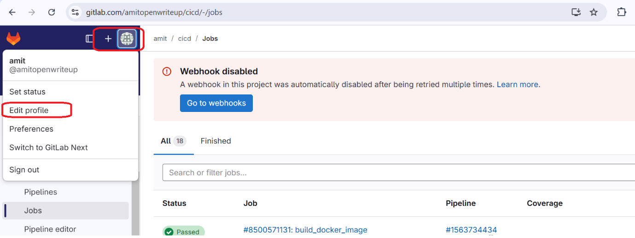

Click on access token

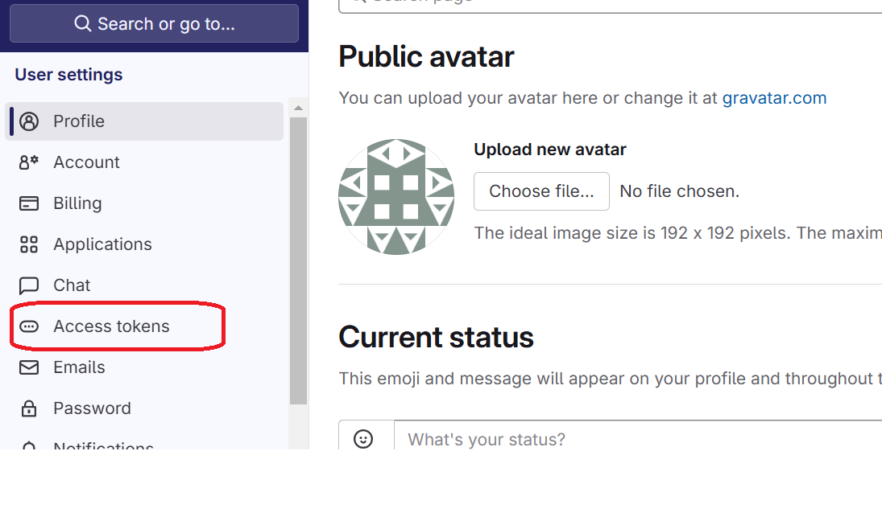

Add new token and provide full scope

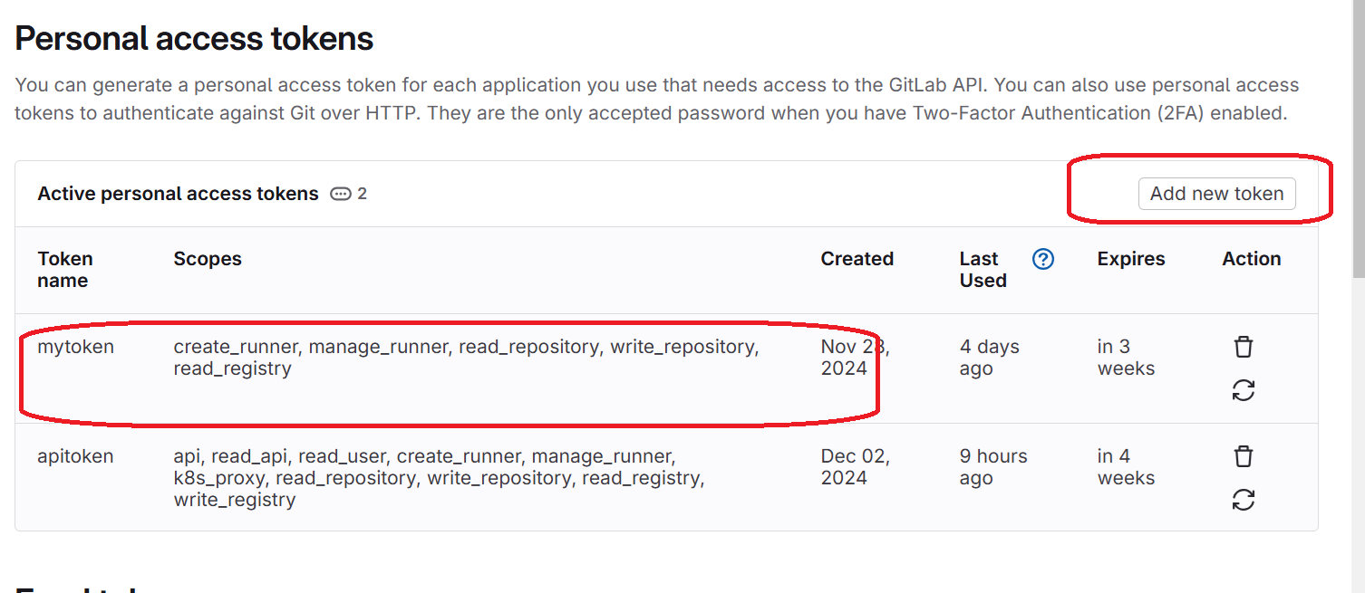

**Note down the token**

Export the token

The GitLab PAT can be exported as an environment variable:

export GITLAB_TOKEN=<token>

bootstrapping the cluster

flux bootstrap gitlab \

--deploy-token-auth \

--owner=amitopenwriteup \

--repository=learning-flux \

--branch=main \

--path=clusters/staging \

--personal

Check all pods running

kubectl get po -n flux-system

Check all services

kubectl get svc -n flux-system

Open the yaml file and check